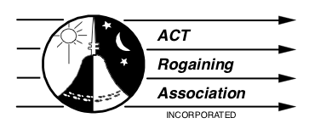

2023 President’s Report
Stephen Goggs
5 March 2023

I’m calling 2022 a ‘continuation year’. The period saw us continue to emerge cautiously from the pandemic fog. Despite the fact our sport was probably one of the safest forms of mass exercise imaginable during a public health emergency - in terms of outdoor social distancing anyway, it was important for us to continue to find ways to ensure we complied with health directions (in two States) throughout. My thanks to organisers and participants alike for abiding by the additional strictures this entailed. The dreaded disease continues to circulate in the community, so we are not out of the woods yet on that score, but there is light at the end of the tunnel.

The series of events during the year continued the fine tradition of taking us to all sorts of places we might not otherwise visit in our daily lives - with the 24 hour championships in northern Kosciuszko National Park and bounding back to Bondo for the Spring event being particular highlights. It was also great to see so many new and young faces continuing to enjoy the annual twilight event, the new traditional virtualgaine, and learning navigation craft at our weekend workshop taking in London Bridge at Googong.

Overall, we had 1852 finishing participants in 825 teams across 8 events for the year, with the Night&Day, Twilight and Metrogaine events proving most popular.

 | Event | Teams | Participants
1 | Twilight | 119 | 326
2 | Paddy Pallin | 74 | 174
3 | Winter 4H | 50 | 128
4 | Metrogaine | 163 | 311
5 | Virtualgaine | 154 | 226
6 | Night & Day | 69 | 201
 |  | 59 | 153
7 | Champs 8/24H | 38 | 101
 |  | 43 | 99
8 | Spring 6/12H | 31 | 76
 |  | 25 | 57
 | Total | 825 | 1852

